North Orange County Community College District
1830 W. Romneya Drive, Anaheim, California 9280
Phone (714) 808 - 4758

INTRADISTRICT CORRESPONDENCE

To: All Staff

From: Beatrice Bates

Date: 12/05/2026

Subject: Payroll Due Dates January 2026 – June 2026

Attached you will find the new schedule of payroll deadlines for the months of January through June. It is very important to adhere to these deadlines in order to ensure proper payment to employees on the specified paydays. The Payroll Department is not obligated to pay any late time sheets submitted after the specified deadlines.

Thank you for your cooperation.

ACADEMIC HOURLY DUE DATES

Following are the deadlines for certificated hourly time sheets.

These employees are found on the HC reporting period:

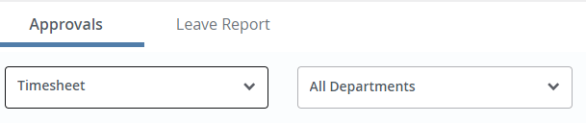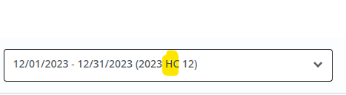

CERTIFICATED HOURLY TIME SHEETS
PAY DATE | TIME CARDS DUE TO PAYROLL | REPORTING PERIOD
01/30/26 | 01/09/26 | 12/01/25-12/31/25
02/27/26 | 02/06/26 | 01/01/26-01/31/26
03/31/26 | 03/06/26 | 02/01/26-02/28/26
04/30/26 | 04/08/26 | 03/01/26-03/31/26
05/29/26 | 05/08/26 | 04/01/26-04/30/26
06/30/26 | 06/08/26 | 05/01/26-05/31/26

** PLEASE NOTE: Academic hourly timesheets should be submitted electronically the last day of the reporting period. This allows Reviewers time
to audit and meet the APPROVER deadlines above. **

CLASSIFIED MONTHLY PERMANENT EMPLOYEE
PAYROLL DEADLINES

Following are deadlines for Classified and Confidential employees. Please note - Leaves and schedules are reported in arrears. Employees must be in full-paid status to receive the ESA.

These employees are on the TP reporting period:
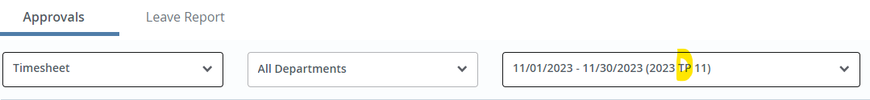

CLASSIFIED MONTHLY TIME SHEETS
PAY DATE | TIME SHEETS DUE | REPORTING PERIOD
01/23/26 ESA (Earned Salary Adv. for January) | 01/09/26 | 12/01/25-12/31/25
02/10/26 Final check for January | 01/09/26 | 12/01/25-12/31/25
02/25/26 ESA (Earned Salary Adv. for February) | 02/06/26 | 01/01/26-01/31/26
03/10/26 Final check for February | 02/06/26 | 01/01/26-01/31/26
03/25/26 ESA (Earned Salary Adv. for March) | 03/06/26 | 02/01/26-02/28/26
04/10/26 Final check for March | 03/06/26 | 02/01/26-02/28/26
04/24/26 ESA (Earned Salary Adv. for April) | 04/08/26 | 03/01/26-03/31/26
05/08/26 Final check for April | 04/08/26 | 03/01/26-03/31/26
05/22/26 ESA (Earned Salary Adv. for May) | 05/08/26 | 04/01/26-04/30/26
06/10/26 Final check for May | 05/08/26 | 04/01/26-04/30/26
06/25/26 ESA (Earned Salary Adv. for June) | 06/08/26 | 05/01/26-05/31/26
07/10/26 Final check for June | 06/08/26 | 05/01/26-05/31/26

For employees less than 100% and or less than 12-months:
** Please be sure to note any changes to their
duty day calendars and submit to Payroll immediately.**

MANAGERS/ADMINISTRATORS/SPA’S

Managers and Spa’s will follow the same deadlines as Classified/Confidential staff. Pay dates are based on retirement system (Academic or Classified).

This group of employees will be found on the MB Leave Report reporting period:

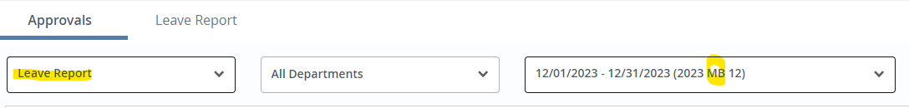

UN-CLASSIFIED HOURLY PAYROLL DEADLINES

Following are the deadlines for un-classified hourly employees including Professional Experts, Student Workers and Temporary Employees.

These employees are found on the HR reporting period in Web Time Entry:

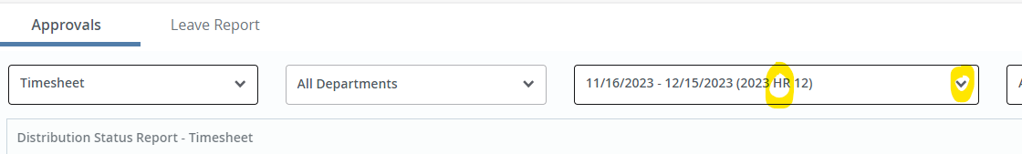

It is very important that all employment forms are filed with the Office of Human Resources before the employee starts to work and routing queues have been set up by the department in NBAJQUE. Access to the electronic timekeeping system will be restricted.

CLASSIFIED ELECTRONIC TIMESEETS MUST BE COMPLETED AND APPROVED
VIA THE EMPLOYEE DASHBOARD (WTE)

UN-CLASSIFIED HOURLY TIMESHEETS
PAY DATE | EMPLOYEE  DUE DATE | APPROVER  DUE DATE | REPORTING PERIOD
02/10/26 | 01/15/26 | 01/22/26 | 12/16/25-01/15/26
03/10/26 | 02/15/26 | 02/20/26 | 01/16/26-02/15/26
04/10/26 | 03/15/26 | 03/20/26 | 02/16/26-03/15/26
05/08/26 | 04/15/26 | 04/21/26 | 03/16/26-04/15/26
06/10/26 | 05/15/26 | 05/21/26 | 04/16/26-05/15/26
07/10/26 | 06/15/26 | 06/22/26 | 05/16/26-06/15/26

** PLEASE NOTE: Temporary hourly employees should electronically submit their hours by midnight, on the 15th of each month. This allows Reviewers time
to audit and meet the APPROVER deadlines above. **

